**INSTALLING APACHE WEB SERVER IN LINUX**

**STEP 1:** Installing Ubuntu using

**Wsl –install command**

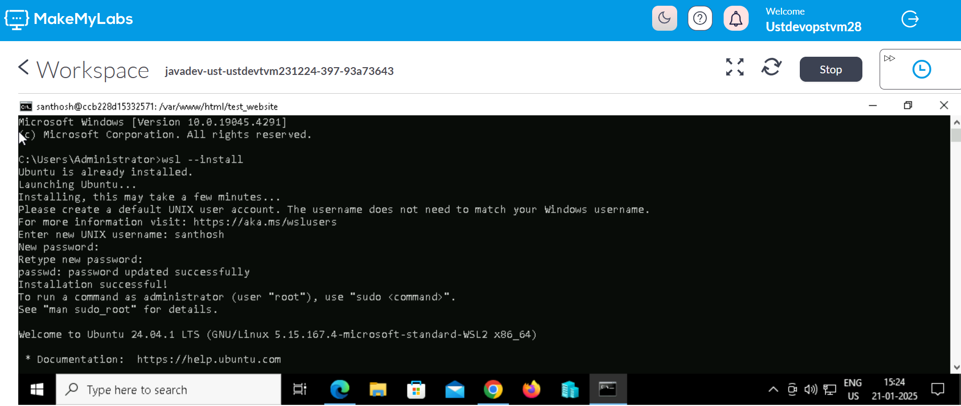

**STEP 2:** Checking the Linux Distribution



**STEP 3:** Install Apache Web Server

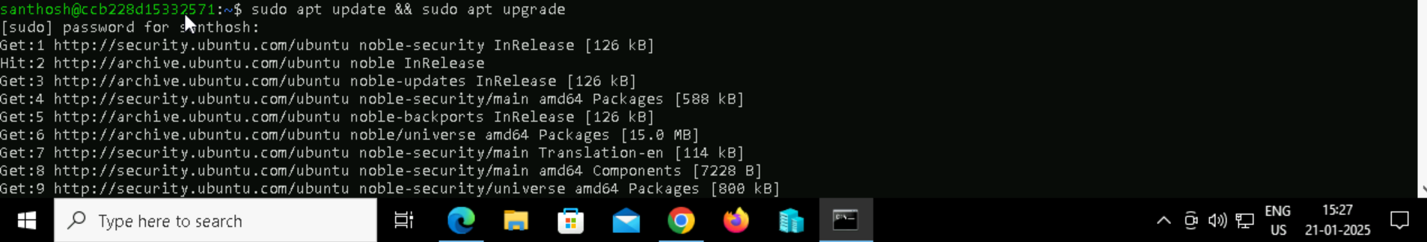

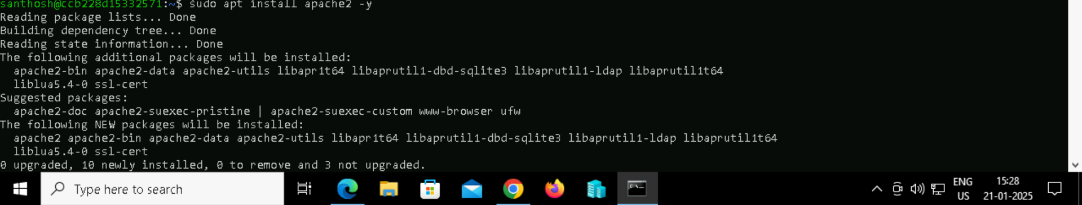

**STEP 4:** Enable the services



**STEP 5:** Test the server by hosting simple Website



**STEP 6:** Adding Index.html along with testing code



**STEP 7:** Adding configuration file and test website we will need the apache website drectory permissions.

So chown and chmod command is used.

